For anatomical brain visualization:

* Anatomy: <http://anatomy.uams.edu/anatomyhtml/neuro_atlas.html>

To Read:

<http://www.cns.nyu.edu/~david/courses/perception/lecturenotes/V1/lgn-V1.html>

<https://en.wikipedia.org/wiki/Visual_cortex>

<http://neuroscience.uth.tmc.edu/s2/chapter15.html>

Optic nerve

Optic chiasm

Lateral geniculate nucleus (LGN)

Primary visual cortex (functionally defined) = v1 = striate cortex (anatomically defined)

* Calcarine sulcus = primarily where the V1 is located <https://en.wikipedia.org/wiki/Calcarine_sulcus>

Extrastriate areas = v2, v3, v4, v5

Optic radiation = connects the LGN to V1

Visual cortex = contains v1 - v5

LOCATING THE THALAMUS

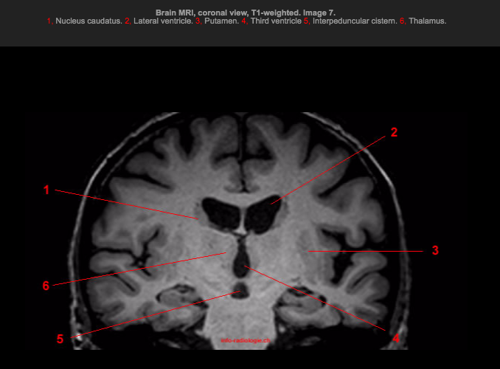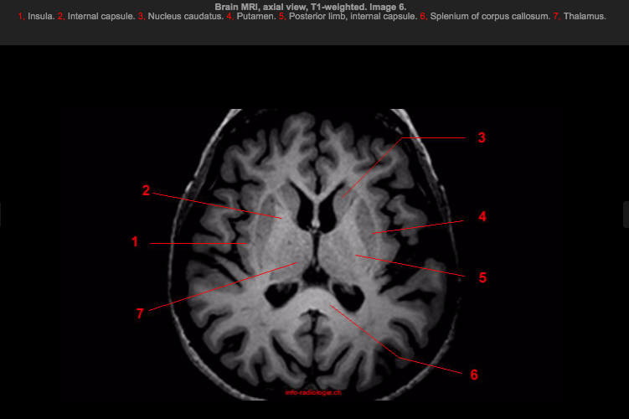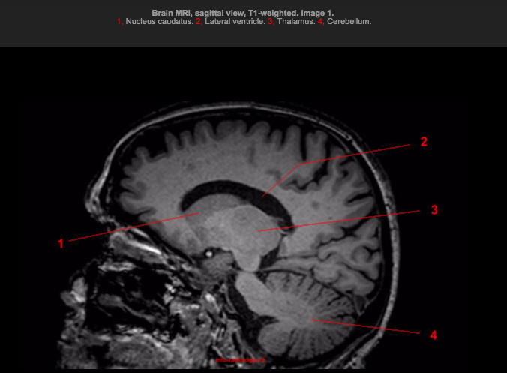

LOCATING THE LGN - lateral geniculate nucleus

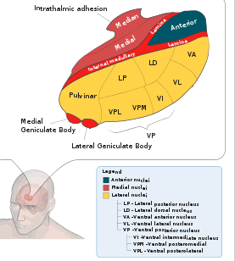

VISUAL HIERARCHY

LGN -> V1

-> dorsal pathway: “how/ where pathway” - motion, location

-> ventral pathway: “what pathway” - recognition, object rep., eventually memory

Receptive field = region of the visual field that changes the firing of an individual sensory neuron

**Grille-Spector, The Human Visual Cortex**:

* Two principles of vision
  + **Functional specialization** - different regions processes different parts of perception
  + **Hierarchical processing** - understanding the visual field is a gradual process of going from a simple to complex/ abstract representation of space

**Kandel, Principles of Neural Science**:

* How does the brain process 2D images and build a stable, constant 3D representation?
  + **Gestalt psychology**: the brain organizes 2D images into stable patterns (gestalts) that remain constant despite variation in images received
    - Example gestalts: **proximity**, a series of dots will look more like rows of dots if the dots in a row are close to each other while the dots in a column are far away. Another gestalt is **similarity**, if the series of dots has the same color in every other column, you’re more likely to see the dots as columns
* How is information, processed in different streams/ pathways, reconciled into a single representation of the visual field?
  + A hypothesis is the idea of a master map, such that the brain creates feature maps for certain ideas of perception (orientation, brightness, shape, size, illumination) and these ideas map onto a master map
  + However, there is no master visual region
* Side note, reading textbooks is great - they give motivations for each subject and more context of the field than journal articles